# COSC345 ASSIGNMENT 1

## Executive Summary

KickOns is a card-based party game to be released on the IOS app store programmed in Swift. KickOn’s will be built with the goal to embrace cultural diversity within social gatherings. Our mission is to bring culturally diverse people together and allow meaningful bonds to be formed on a deeper level than our competition. We do this by striving to create “a game for everyone” with the hopes to make an ecosystem of user-generated decks which are easily shareable with friends.

## Introduction

Party games have existed since mankind’s earliest celebrations. These games have been a way that people have bonded and form deeper relationships with each other. In our technological age nothing has changed except the platform for which we play these games. With the digital revolution came digital party games, predominantly mobile based. With rapidly growing popularity and profitability we wish to create our own implementation embracing cultural diversity and fulfilling the shortcomings of our competition. Some examples of these successful party games are Picolo[1] and Ipuke[2] each with millions of downloads across the Google Play Store and Apple App Store and growing.

## Organisation- People and Roles

Our team consists of five members: Luka, Akshay, Enrico, Yashree, and Kurt. Having a large team means we can bring a lot of experience into our group project.

Table 1: shows members strengths and weaknesses

|  |  |  |
| --- | --- | --- |
| **Team Member** | **Strength(s)** | **Weakness(s)** |
| Luka - Team Lead | Experience in Java, C-like languages and mobile development with the Oculus Quest and other android devices. Background in Computer and Finance and was primarily picked to ensure a potentially profitable app as well as success in COSC345. | Limited experience working in IOS systems and with Swift. Tends to get distracted from projects. Time management. |
| Akshay - UI designer | Has experience in Java and Python. He has some experience in Adobe Photoshop which means he has some experience in graphic design. He double majors in computer science and neuroscience in hopes of going into artificial intelligence research. We chose Akshay because of his ability to come up with graphic designs and his coding abilities. | Has limited knowledge and experience in using coding languages such as swift for IOS. |
| Enrico - Software developer | He has experience in Java, HTML, CSS, JavaScript, and Python. He studies Computer Science and Software Engineering. His time management is his greatest asset, hence why he is tasked with project scheduling. | Almost no knowledge on Swift, XCode, and developing mobile applications. Memory managed programming and program efficiency. |
| Yashree -Software Developer | Software design models, time management. has experience with Java, some basic HTML, CSS, and SQL. | Limited knowledge in  developing mobile  applications, as well as  Programming in XCode. Testing. Programming with  memory managed  languages. |
| Kurt - Software Developer | Experience with python and java, and a small amount of knowledge in HTML and CSS, experience with front-end development | No previous experience with programming in mobile based languages, and poor time management skills. |

## Project Description

**The aim of our game is to obtain the least number of penalties.** A set of cards make a deck, with each deck intended to encompass a theme. These decks will be able to be created and shared by users specified below. There are 4 types of cards within a deck:

* **Normal cards:** These are common cards making up much of the deck that have questions, actions, or games. Failure to answer the questions or complete the challenges lands a player with penalties.
* **Handicap:** These are cardsaffecting a single player. This is a negative persistent penalty which affects the player unlucky enough to be chosen by the roulette wheel. Persists until the paired closing card comes several cards later.
* **PowerUp:** These cards affect a single player. This is a positive persistent benefit which affects the player lucky enough to be chosen by the roulette wheel. Persists until the paired closing card comes several cards later.
* **Law:** Finally, there are Law cards which affect all the players in the game. These cards change the paradigm of the game intended to encourage interaction between players.

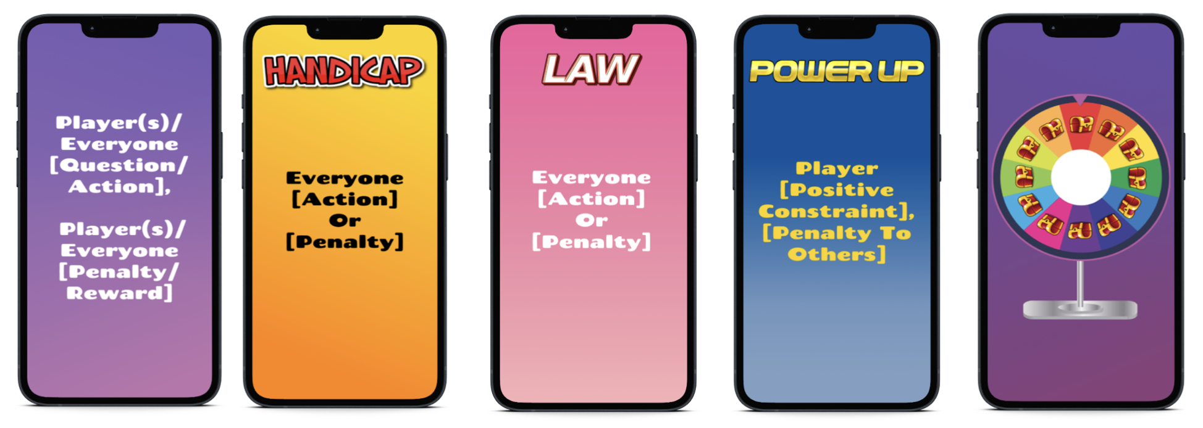

## Game Play Process

The game will work in a similar way to Picolo, as this app is the most successful in the growing party app market. The general gameplay of Picolo is that one player is the speaker (holding the device) and all players sit in a circle and follow the instructions/prompts of the game. One of the strengths of Picolo is that there are no rules to remember as the app is aimed to be simple and guide participants through the speaker reading cards to the group with members completing instructions to avoid getting penalties. In KickOns, on launch the app will:

1. Prompt the Speaker (device holder) to enter the names of all players.
2. Choose a deck. Starter decks will be supplied or have the option of choosing previously created decks or using friends’ decks.
3. Once in game, KickOns will randomly choose cards to present to the speaker with randomly generated player names. Law, Handicap and PowerUp cards are intended to be rare, exciting cards. When one of these cards is next on the stack a player's name will be randomly chosen. Then the roulette wheel graphic will be activated spinning until falling on a chest containing either their reward or punishment. The speaker is intended at this point to rotate the device to the group so they can watch in anticipation.
4. The game continues with players attempting to obtain the least number of penalties until the deck is complete.
5. The Speaker may then replay the deck or choose another.

The graphics for each card are pictured above with scaffolds of what a card prompt will look like. Before we can create an ecosystem of user-generated decks we will need to create some “starter decks'' so players can quickly jump into a game. Below we have examples of what the content of our starter decks will be like,

[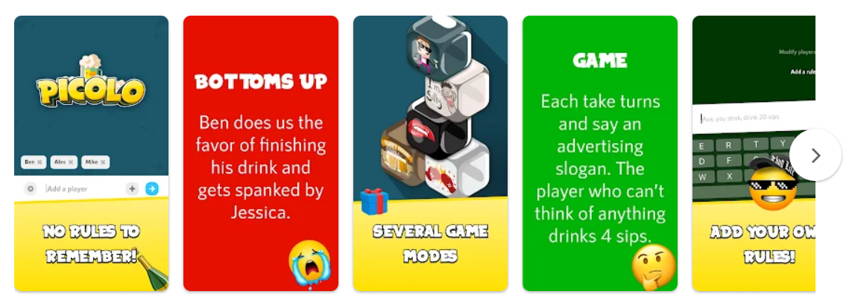](https://apps.apple.com/us/app/picolo-party-game/id1001473964)[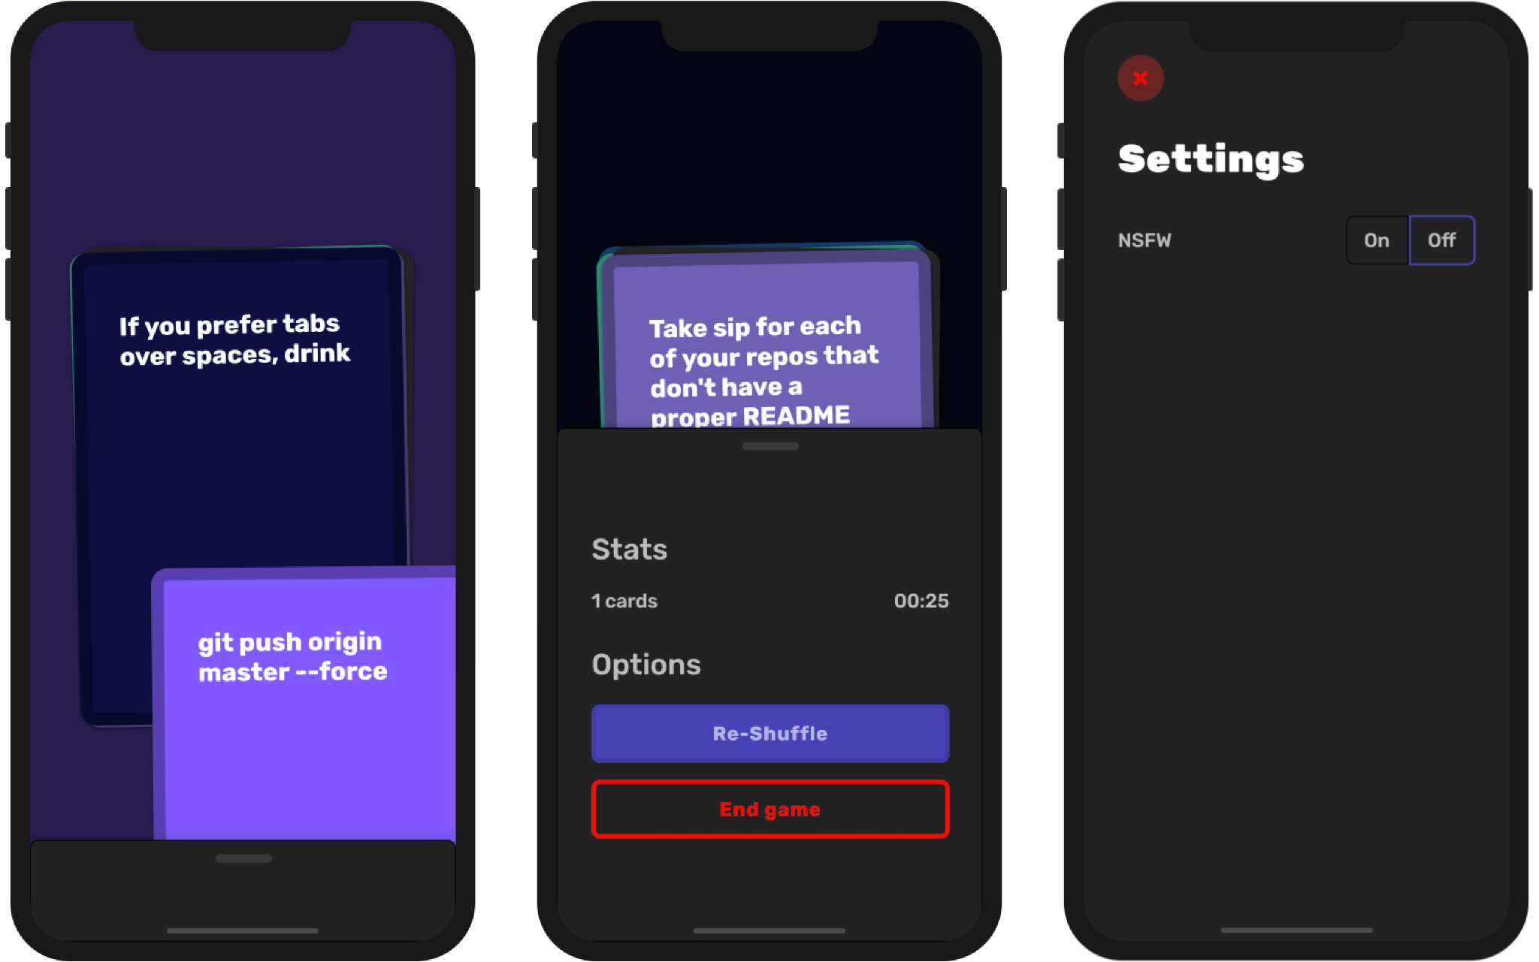](https://github.com/ninest/Shots)

## Competitor Success and Target market

As mentioned, Picolo and other similar apps have been gaining massive popularity in the IOS app store charts. Paired with an inflated subscription fee these apps are generating modest revenues and seem set to continue growth into the future.

Our target Audience will be two pronged,

* We wish to appeal to the users of Picolo style apps as a cheaper alternative with limitless content. Our main advantage over Picolo style apps is our content base will grow as our user base does, for free. KickOn’s will never need to pay for writers to design more card content. This target audience is estimated to be western youth aged 18-25.
* With Diversity and Inclusion at the roots of the app we hope to attract youth from other backgrounds (18-25) as well as break into the more mature market of 25–35-year-olds as the “go-to” hosting game.

## Competitive Advantage and Diversity

The main weakness of apps such as Picolo and Ipuke is the inability of creating your own decks enabling diverse card content. This often results in users of these apps running through all the content quickly unless they are willing to shell out for inflated subscription fees. On top of that Picolo has the weakness of much of its card content only appealing to people of the same cultural background, primarily western youth. Many cards revolve around general surface level directions and questions. We wish to create an app which will bring culturally diverse people together.

Our app will have a competitive advantage over Picolo by embracing the diversity of people’s backgrounds by allowing user-generated decks which can be stored and shared with friends. Our app will also (when launched) be free or substantially cheaper than Picolo which currently charges weekly premium fees of $7.99 NZD.

As these decks are user-generated, the content between decks can be diverse and specific to a user’s cultural background. The app will appeal to people from a wide range of backgrounds by having the ability to let anyone build card content. Users can make decks about whatever they are interested in. It can be about their occupations, where they are from, or even their hobbies. This allows diverse groups of people to be brought together at social gatherings and embrace themselves.

A way to further embrace diversity is by eventually adding functionality and a way to connect people. This will be through allowing them to share decks through phone numbers, social media, or location. The card creation will be controlled by a template depending on each card type allowing any variety of prompts while maintaining coherence of card content and between card types.

## Resource requirement

The resources that are needed for this software development project are kept to a minimum. We have identified certain resources that are needed. Because we are creating an app for Apple, we need to have access to and download the swift programming language to which is created by apple for building apps. Which also comes with Xcode which is an Integrated Development Environment (IDE) that includes a set of tools to aid in the development of our app. We also need a database provider, a Mac computer to code on, and an iPhone to test our game.

[**https://app.smartsheet.com/sheets/wHgf84Jfm54F8w4mx5h4FxXHmxR74wVJqFg2qQC1**](https://app.smartsheet.com/sheets/wHgf84Jfm54F8w4mx5h4FxXHmxR74wVJqFg2qQC1)

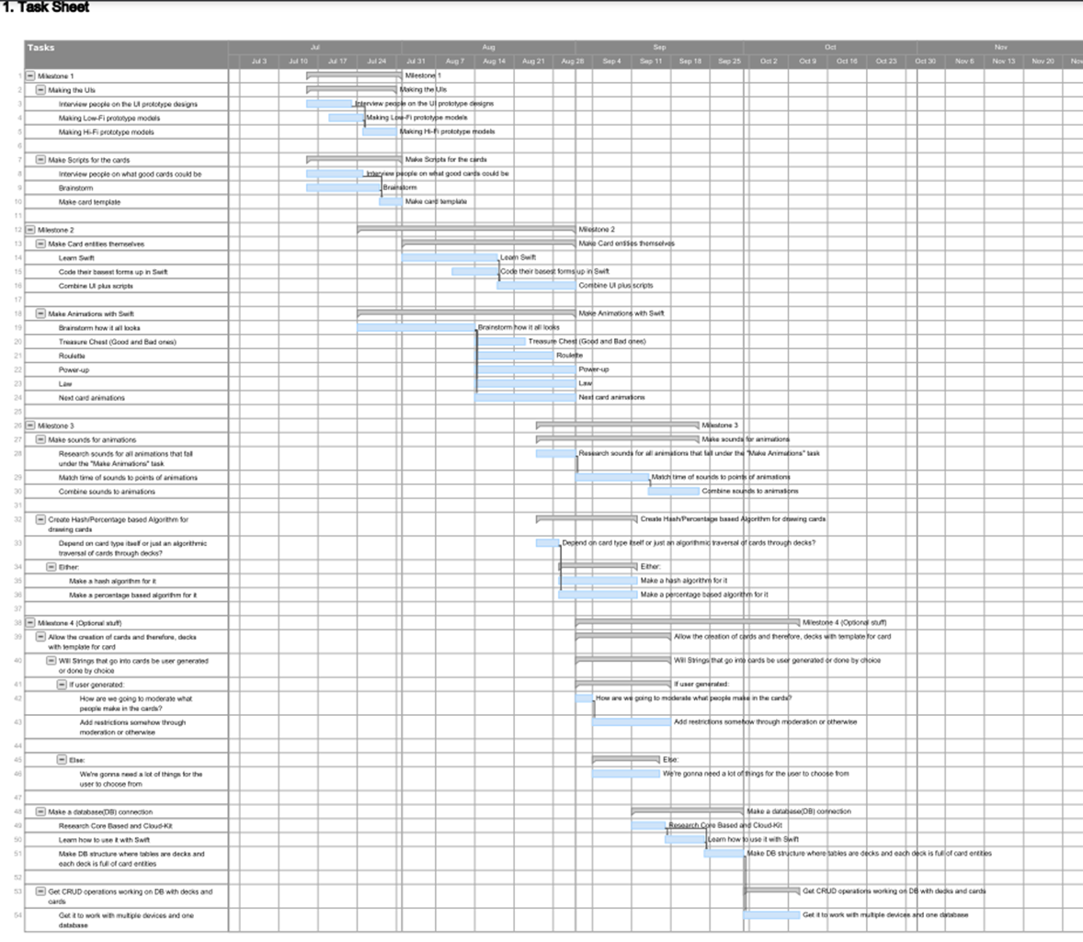

## Risk analysis

Risk management is a technique for avoiding or minimising the consequences of unplanned occurrences that can occur during a project's life cycle.

|  |  |  |  |  |  |
| --- | --- | --- | --- | --- | --- |
| Risk | Likelihood (1-10) | Impact (1-10) | Exposure | Priority (1-5) | Risk Plan |
| Group member sickness therefore inability to work on the project | 10 | 3 | 30 | 2 | Due to the high prevalence of covid this has a high likelihood hence would be high, but we already have the resources to work from home eg: zoom, remotely working by pulling and pushing work from github |
| Change in project scope | 6 | 9 | 54 | 3 | Get together with the team and reflect on what went wrong and how to fix it. |
| Members of the team don't have enough experience | 7 | 7 | 49 | 4 | The tasks should be delegated based on what the members are the most comfortable working on |
| Lack of group member productivity | 6 | 10 | 60 | 5 | Making sure that we keep track of how each member are progressing with their part of the project eg: stand up’s |
| Change in project requirements | 6 | 7 | 42 | 4 | Roll back through the development life cycle of the project to where the change is and work from there. |
| Scheduling constraints (inability to meet at the same time) | 7 | 10 | 70 | 5 | Able to organise suitable times that work for everyone to meet up and work on the project. |
| Team member suddenly has to drop the class (extreme) | 4 | 10 | 40 | 1 | We are well underway with this semester so team members dropping the class now would be less of a concern as it is less likely to happen. |
| Testing reveals a major issue embedded deep in the code. | 8 | 10 | 80 | 4 | First, we will attempt to find the bug and repair it. If the bug is impossible to find or too large in scope to fix, we will examine the feature and find alternatives to avoid the bug. |
| Having poor quality code | 8 | 9 | 72 | 4 | Having constant checks over the written code by our team members to ensure good quality code. |
| Development software/IDE breaks | 7 | 8 | 56 | 3 | Uninstall latest update in hopes that a quality update is what crashed it. If something else caused it to break, use lab computers. Save all the time. |

## Monitoring of the Project

Our team has a variety of means to communicate with the group constantly. One of these channels is through our classes with each other during the semester, and this is constant as we have classes every working day of the week. Another viable communication channel is via Facebook messenger, as we have set up a group chat to report and update our team. We also have a Trello dashboard and a Smartsheet Gantt chart to keep up to date on tasks and who are responsible. This way, any of us can step in to help when we see that a task is running a little late to completion.

## When reports are to be delivered

We have 4 major milestones to meet in delivery of the overall project. The first major milestone is to be delivered on Friday the 29th of July, in the form of a report on the plan for development of the application. The next major milestone in the development is the first release alpha of the application, due on Friday the 26th of August, which includes a working release, the source code, and documentation on the source code. The third milestone is the working beta release of the application, with CI and analysis report, which is due on Friday the 16th of September. The final working release milestone is to be delivered on Friday the 7th of October, and includes a fully working, debugged and documented application with included details gained from user testing.

## Conclusion

To summarise, we are creating a party game app with the aim to bring together culturally diverse people together to socialise. We do this by giving the users of the game the ability to create their own custom deck of cards, therefore we have a wide diversity/range of topics that people can play with. We also included as many colours as possible into the UI of the game to promote the idea of diversity.

1. <https://apps.apple.com/us/app/picolo-drinking-game/id1001473964>
2. <https://apps.apple.com/us/app/ipuke-the-drinking-game/id596393583>